GeneLab Standard Operating Procedure: TRIzol RNA Extraction with QIAGEN RNase-Free DNase Set and QIAGEN Allprep

*May 2020*

*Version 1.00*

# 

Document Revisions

|  |  |  |  |
| --- | --- | --- | --- |
| Document Number | Revision Number | Date | Description of Changes |
| GL-SOP-3.2 | 1.00 | May 2020 |  |
|  |  |  |  |
|  |  |  |  |
|  |  |  |  |

# Scope and Purpose

This procedure describes the steps required to extract RNA from mammalian tissue using the TRIzol reagent for isolation and Qiagen Allprep mini kit for clean-up. In addition, in this procedure we describe steps for depleting the isolated RNA from DNA using QIAgen RNase-Free DNase set. This step is required for RNA that will be used for sequencing.

It is strongly advised to read the AllPrep DNA/RNA Mini-Handbook in full.

**Some buffers in this kit contain guanidine salt and are not compatible with disinfectants containing bleach.**

This protocol is used mainly for RNA isolation from the following tissues:

* Skin

Starting material: 20-50mG

Expected yield: 0.5uG of RNA/mG of tissue. (+/-0.3)

* Muscles (Quadriceps, Tibialis anterior, Gastrocnemius)

Starting material: TA 20-30mG, Quad 50mG, GST 30-50mG

Expected yield: TA 0.28uG of RNA/mG of tissue, Quad 0.1uG of RNA/mG of tissue, Gastrocnemius 0.15uG of RNA/mG of tissue

# Equipment and Consumables

1. Eppendorf Centrifuge 5424/5424 R
2. DNA LoBind Microcentrifuge Tubes1.5mL (Thermo Scientific, Cat#13-698-791)
3. Bench top microcentrifuge to accommodate 1.5mL tubes (Thermo Scientific Cat#75004081 or similar)

# Reagents

1. TRIzol reagent (Invitrogen Cat#15596018)
2. Allprep RNeasy Mini kit (Qiagen, Cat#80204)
3. RNeasy Mini Spin Columns in 2mL collection tube
4. Buffer RLT Plus
5. Buffer RW1
6. Buffer RPE
7. RNase-Free Water
8. RNase Free DNase set (Qiagen, Cat# 79254 or Cat#79256)
   1. RNase-free DNase I
   2. RNase-free Buffer RDD
   3. RNase-free water
9. Mol. grade isopropanol, 100% (Fisher Scientific, Cat#BP2618500 or similar)
10. Non-denatured, mol. grade ethanol, 200 proof (Fisher Scientific, Cat#BP2818100)
11. Mol. grade chloroform (Fisher Scientific, Cat#ICN19400290 or similar)
12. RNase/DNase free water (Thermo Fisher Scientific, Cat#10977015 or similar)
13. RNaseZap Decontamination Solution (Thermo Fisher Scientific, Cat#AM9782 or similar)

# Procedure Workflow

Add your workflow diagram here.

# Procedure

Initial prep:

* Pre-chill microcentrifuge to 4°C.
* **Make sure 100% EtOH is added to all the QIAGEN concentrated buffers RPE and RW1**
* Set a microcentrifuge to room temperature (25°C).
* Prepare a working rack with pre labeled tubes as illustrated in **below:**

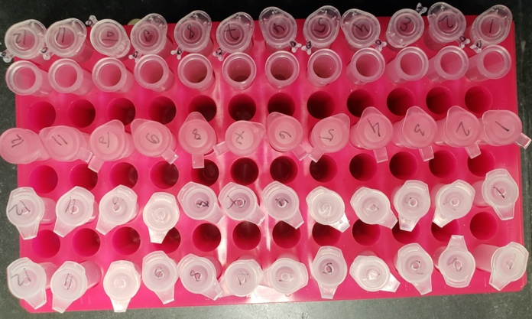

Figure 1: Tube layout on a tube rack

**RNA Isolation**

1. Follow tissue homogenization SOP #2.1 or SOP#2.2 (SOP#2.2 protocol favors higher lysis buffer volume: 1mL).
2. After centrifuging the lysate and transferring the supernatant into a new tube, incubate at RT for 5 min.
3. Add 200uL chloroform (for 1mL TRIzol).
4. Close tubes and shake vigorously for 15sec.
5. Incubate for 3min at RT.
6. Centrifuge at 12,000 RCF for 15min in 4˚C. The mixture will separate into a lower phenol-chloroform phase, and interphase, and an upper aqueous phase. RNA remains in the upper aqueous phase.
7. Transfer the upper phase of the supernatant (~500-600uL) into 1.5mL tube and add 500uL 100% isopropanol (for 1ml TRIzol).
8. Incubate for 10min at RT.
9. Centrifuge at 12,000 RCF for 10min in 4˚C.
10. Discard the supernatant.
11. Wash pellet by adding 1mL of freshly prepared 75% EtOH (per 1ml Trizol, mix by tapping) and centrifuging at 7,500 RCF for 5 min in 4˚C.
12. Discard the supernatant.
13. The pellet might be loose, take care to discard supernatant without losing it.
14. Repeat step 11-12.
15. Air dry the pellet until no liquid is present in the tube, do not over-dry the pellet as this will greatly decrease solubility.
16. Resuspend the pellet with 100uL RNase free water.

**RNA Clean Up**

1. Set the centrifuge to 25˚C. ALL remaining centrifugation steps have to be performed at RT.
2. Make sure the RNA pellet is fully resuspended
3. Add 350uL of RLT buffer and vortex until well mixed.
4. Add 350uL of freshly prepared 70% ethanol to the flow through from step 18, (adjust based on the starting RLT buffer volume). Mix well by pipetting and do not centrifuge. Proceed immediately to step 20.
   1. For maximum RNA yields from liver, 50% ethanol (instead of 70% ethanol) should be used. Based on AllPrep DNA/RNA Mini-Handbook pg26.
5. Transfer 700uL of the sample into RNeasy Mini column (pink) placed in a 2ml collection tube, close the tube gently.
6. Centrifuge at 10,000 RCF for 30sec at RT, discard the flow through.
7. Add 500uL of RPE buffer onto RNeasy Mini column (pink column), and centrifuge at 10,000 RCF for 30seconds. Discard the flow through.
8. Add 350μL of RW1 buffer onto RNeasy Mini column (pink column), and centrifuge at 10.000 RCF for 30seconds. Discard the flow through.
9. Prepare DNase stock solution (if no current stock is available) and DNase master mix.
   1. Dissolve the solid DNase I (1500 Kunitz units) in 550μL of the RNase-free water provided. Take care not to lose any of the solid DNase I when opening the vial.
   2. For long-term storage of DNase I, transfer the stock solution from the glass vial, aliquot in several tubes, and store at -20°C for up to 9 months. Thawed aliquots can be stored at 2-8°C for up to 6 weeks. Do not re-freeze the aliquots after thawing.
   3. To make the master mix for each sample combine 10uL DNase and 70uL RDD buffer.
   4. *Never vortex reconstituted DNase I!*
10. Pipette 80uL DNase I master mix directly onto RNeasy Mini column membrane of each sample and incubate at room temperature for 30min.
11. Add 350μL Buffer RW1 on the RNeasy Mini column. Close tube gently.
12. Centrifuge at 10.000 RCF for 2 minutes to wash column. Discard flow through.
13. Add 500μL Buffer RPE on the RNeasy Mini column. Close tube gently.
14. Centrifuge at 10,000 RCF for 2 minutes to wash column. Discard flow through.
15. Repeat step 29.
16. Transfer the column in to a new 2ml collection tube and centrifuge at full speed for 2min to dry the RNeasy silica-gel membrane. Discard flow-through.
17. Transfer RNeasy mini column to a new 1.5mL collection tube.
18. Add 30 - 50μL RNase-free water directly onto RNeasy silica-gel membrane. Incubate at RT for 10min.
19. Close tube gently, and centrifuge at 8,000 RCF for 1min.
    1. If the volume recovered is lower than the anticipated amount, perform additional spin of 1min at full speed.
20. Following SOP#4.2 perform RNA quantification using Qubit fluorimeter.
21. Following SOP#4.3 perform RNA quality analysis using Bioanalyzer.
22. Aliquot the generated samples following SOP#1.1.